Scenario: check windowhandles
Step: Launch "WindowHandlePage" WebPage - PASS
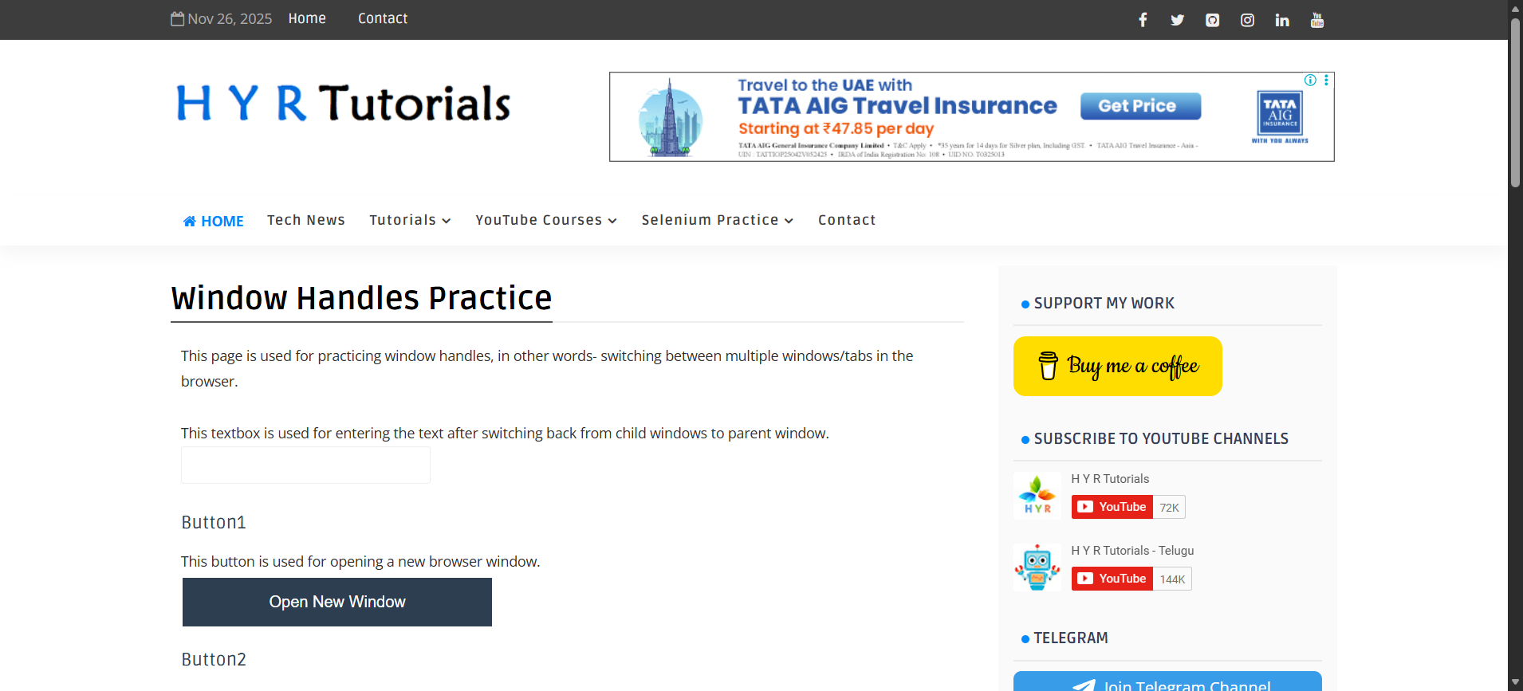
Step: User click the "Tab_Button" element at "WHPage" page - PASS
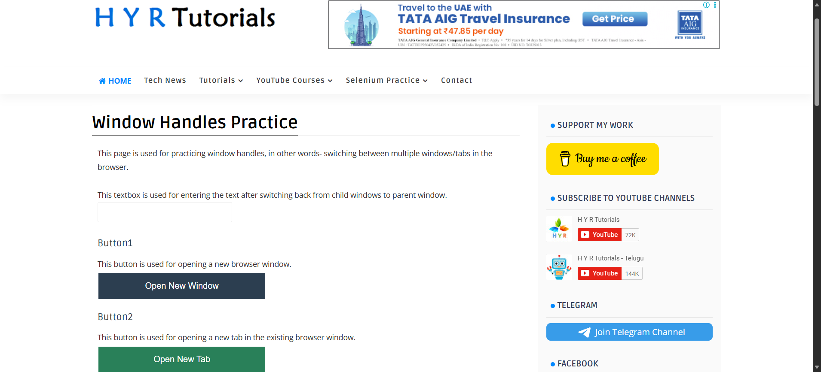
Step: And the user waits for "2" seconds - PASS
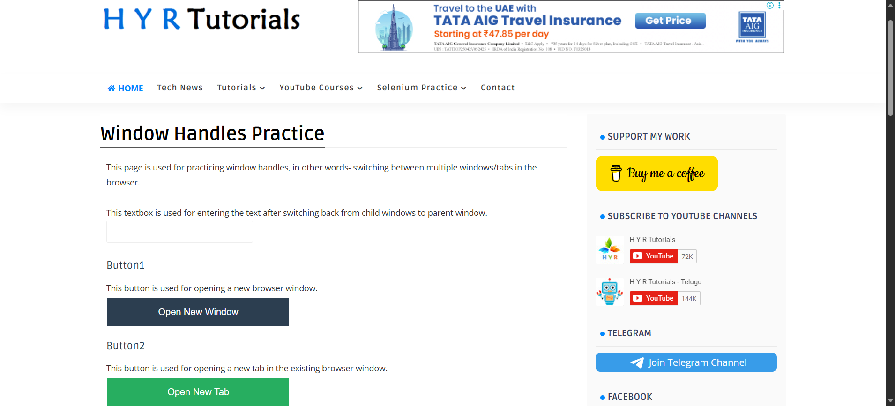
Step: Then the user switch to "firstWindow" - PASS
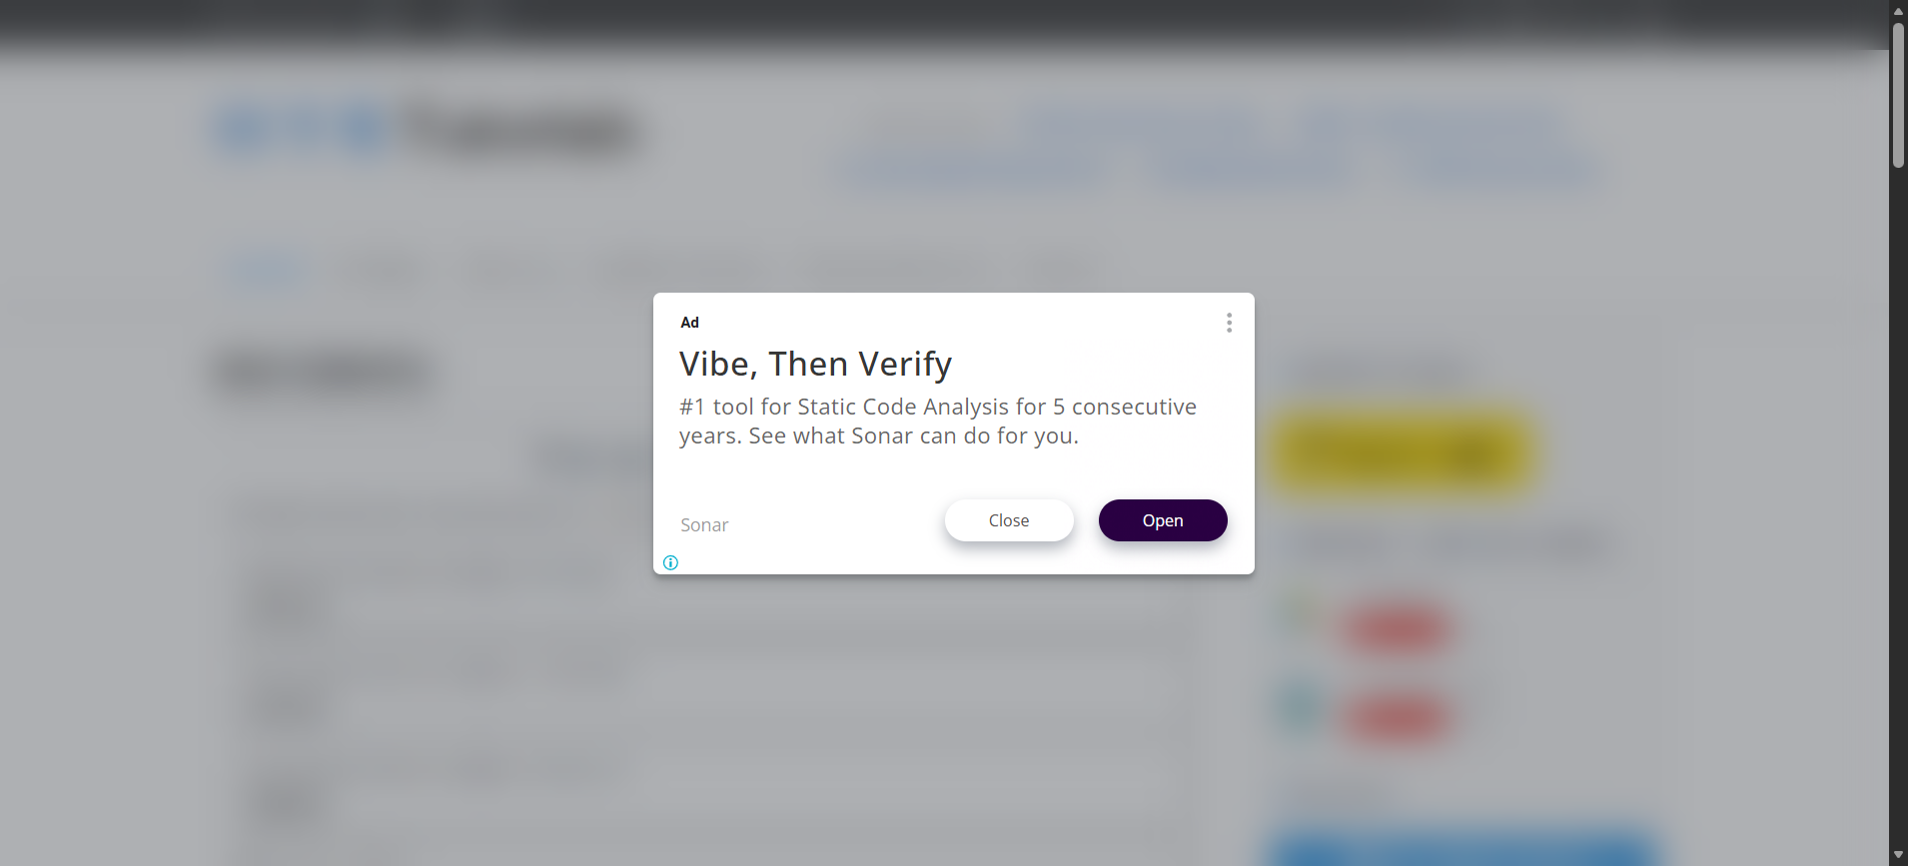
Step: Then the user switch to "firstWindow" - PASS
Step: And the user waits for "10" seconds - PASS
Execution Summary:
Total Steps: 6
Passed: 6
Failed: 0

